Date access: 2020-03-09

<http://wjw.beijing.gov.cn/wjwh/ztzl/xxgzbd/gzbdyqtb/202001/t20200130_1621741.html>

From 8 am to 6 pm on January 26, 9 new cases of pneumonia infected with new coronavirus were added to the city

Date: 2020-01-26 Source: Beijing Municipal Health Commission

        From 8 am to 6 pm on January 26, 9 new cases of pneumonitis infected with new coronavirus were added to the city, of which 3 were close contacts of previously confirmed cases, and 1 was close contact of newly screened positive to-be-diagnosed cases. All have been sent to designated medical institutions for treatment.

As of 18:00 on January 26, the city has accumulated 63 confirmed cases, including 1 in Dongcheng District, 5 in Xicheng District, 11 in Chaoyang District, 14 in Haidian District, 4 in Fengtai District, 2 in Shijingshan District, and 6 in Tongzhou District. There were 1 case in Shunyi District, 3 cases in Daxing District, 5 cases in Changping District, and 11 cases came from overseas.

**1月26日8时至18时，本市新增9例新型冠状病毒感染的肺炎病例**

日期：2020-01-26 来源：北京市卫生健康委‍

        1月26日8时至18时，本市新增9例新型冠状病毒感染的肺炎病例，其中3名为此前确诊病例的密切接触者,1名为初筛阳性待确诊病例的密切接触者。目前均已送至定点医疗机构进行救治。

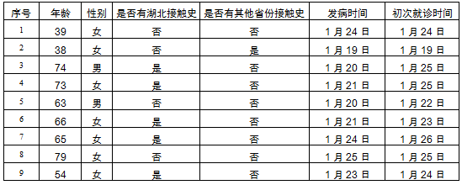

        截至1月26日18时，本市累计确诊病例63例，其中东城区1例、西城区5例、朝阳区11例、海淀区14例、丰台区4例、石景山区2例、通州区6例、顺义区1例、大兴区3例、昌平区5例，外地来京人员11例。